NEHA BAHL-A003

In the AWS Management Console, type “S3” in the search bar and select “S3” from the dropdown.

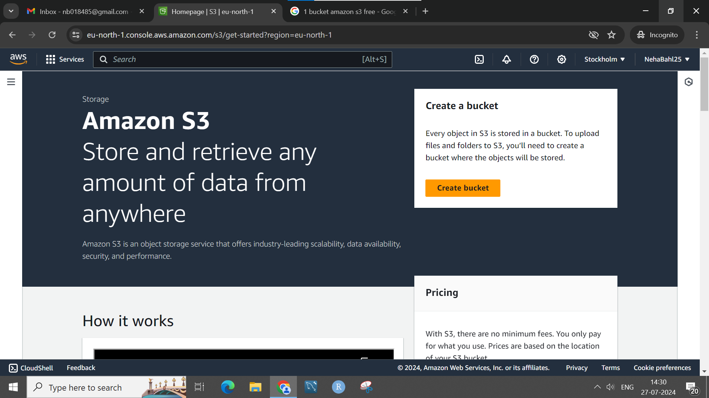

To create a new bucket, click on the “Create bucket” button.

* **Bucket Name**: Enter a globally unique name for your bucket.

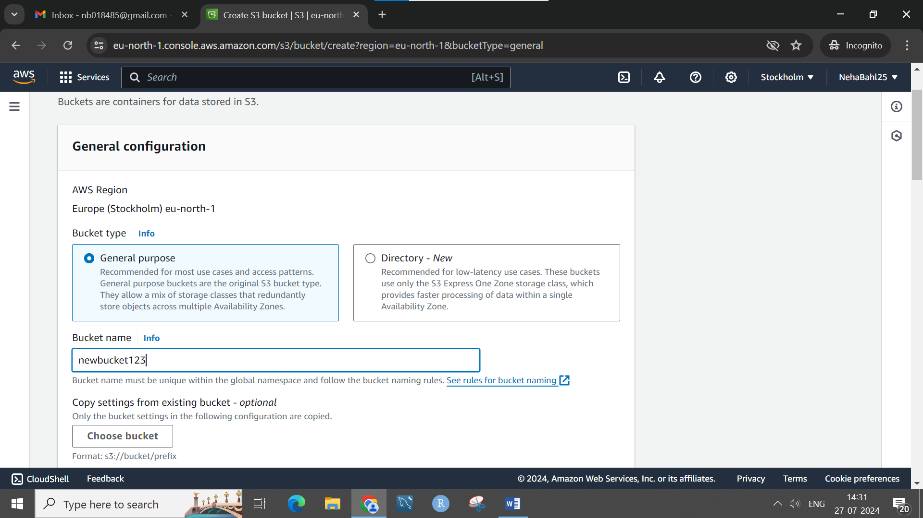

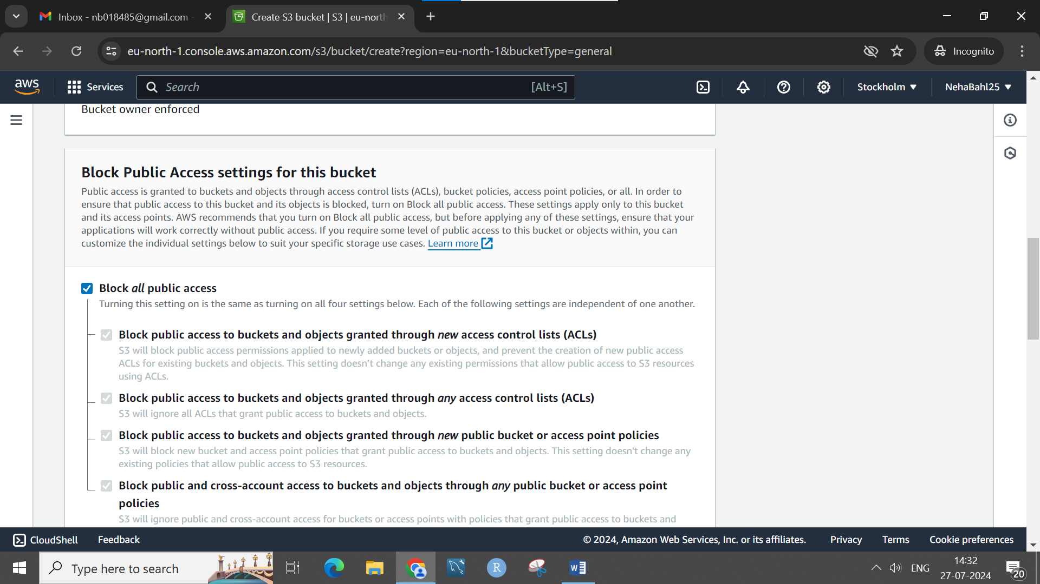

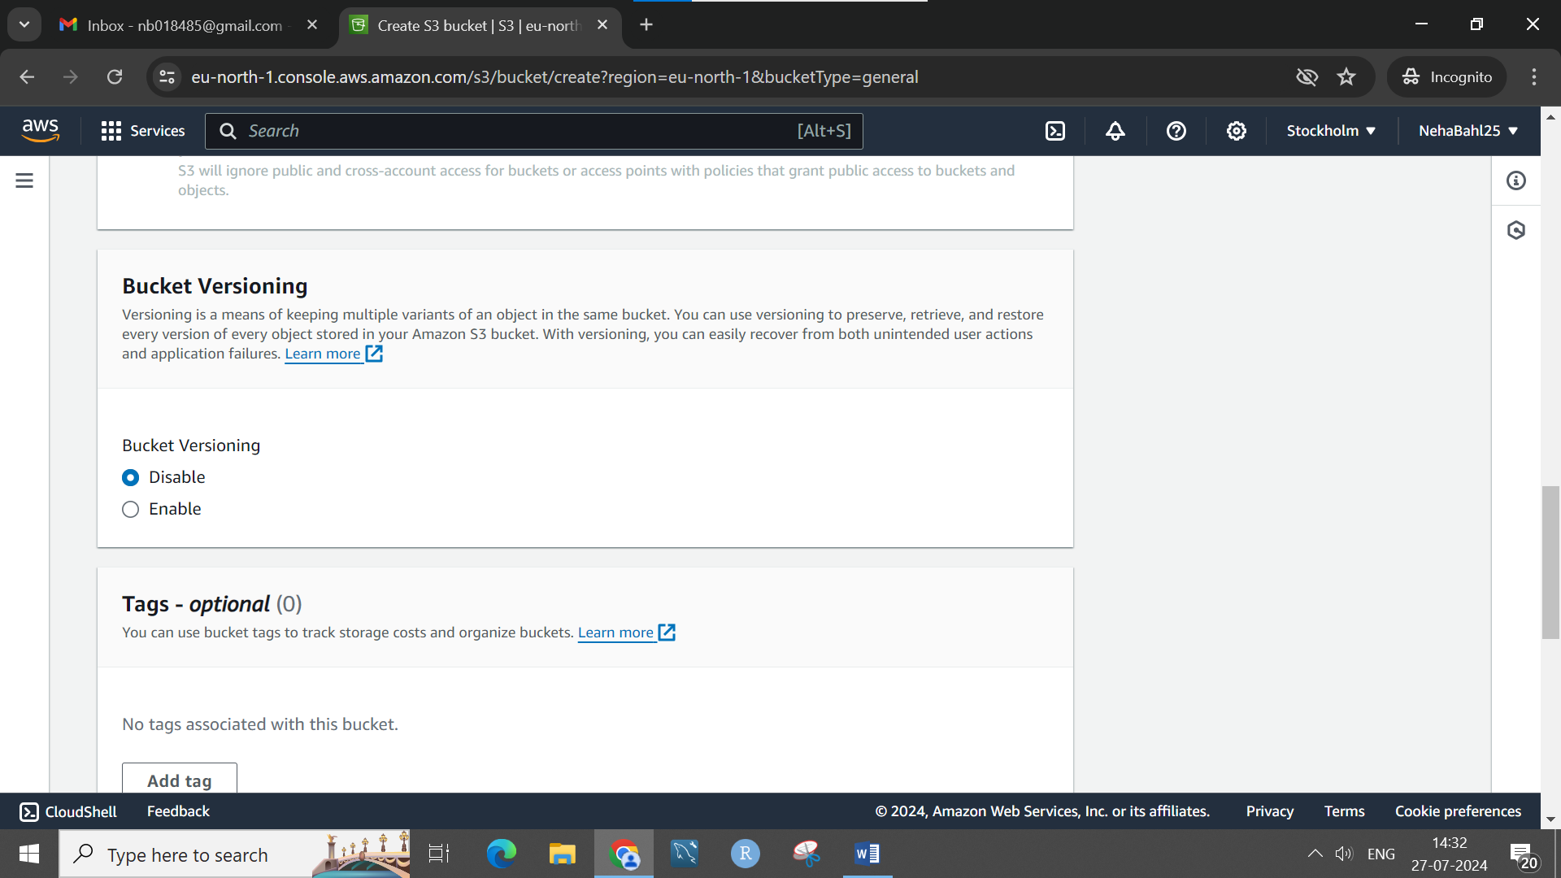

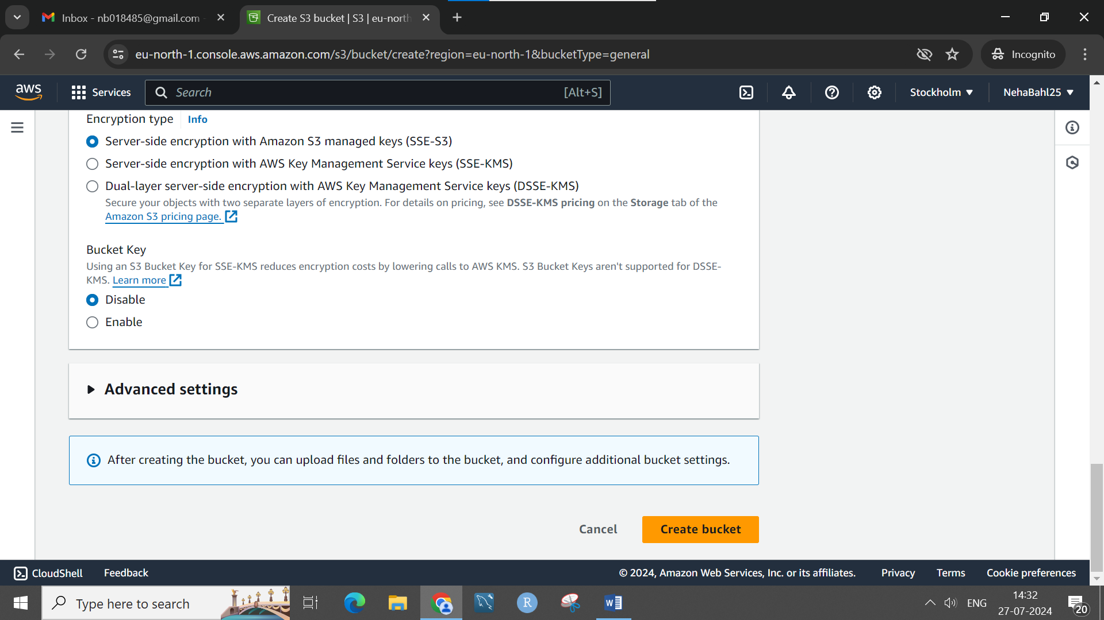

Block public access, disable versioning and bucket key.

Click on “Create bucket” at the bottom.

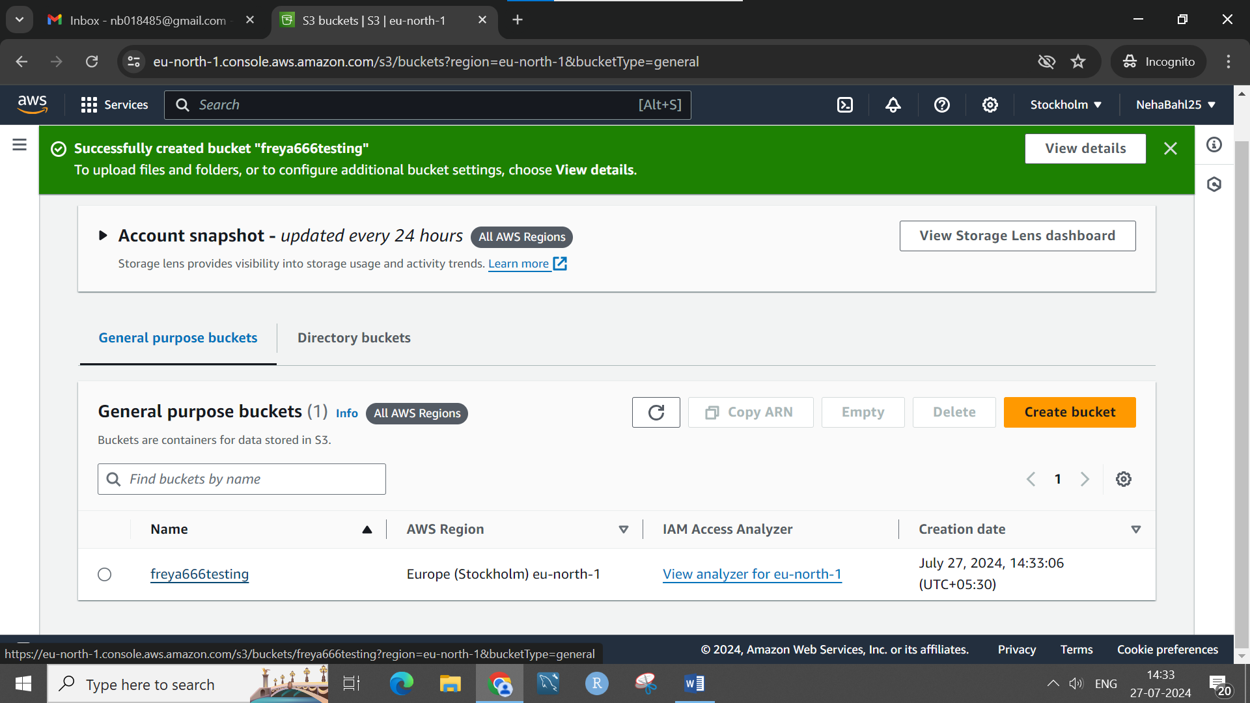

Bucket is created.

• Go to the **Objects** tab in your bucket.

• Click on the “Upload” button.

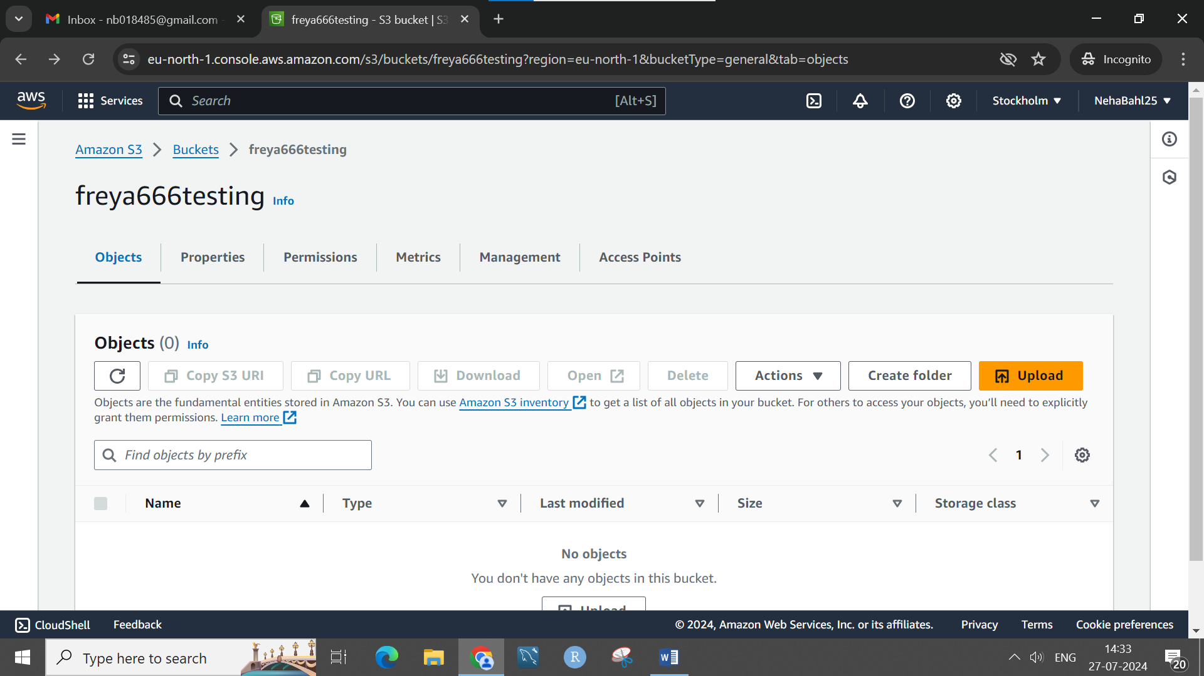

• Drag and drop your file or use the “Add files” button to select it.

• Click on “Upload” to start the upload process.

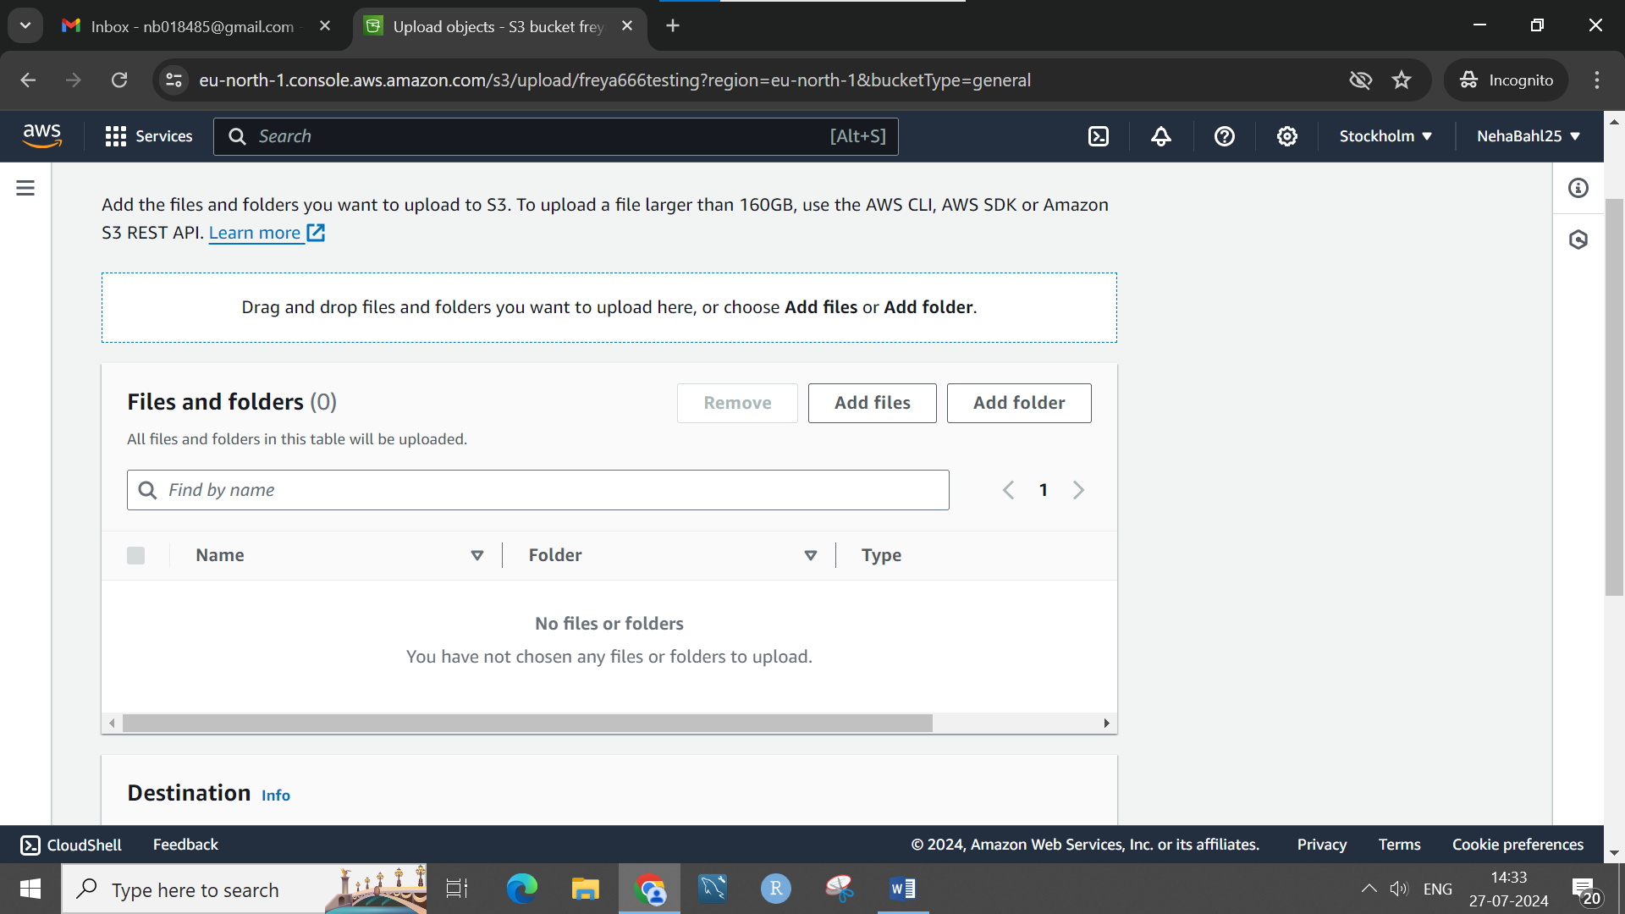

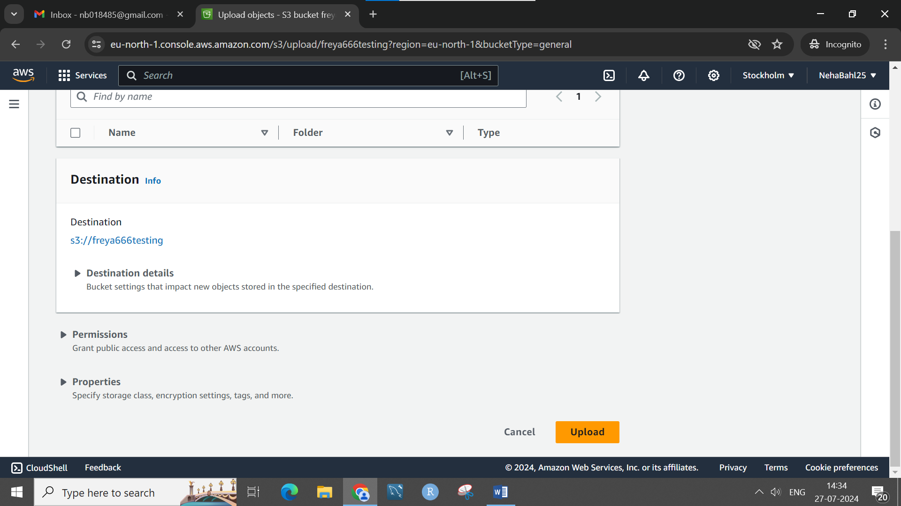

Upload successful.

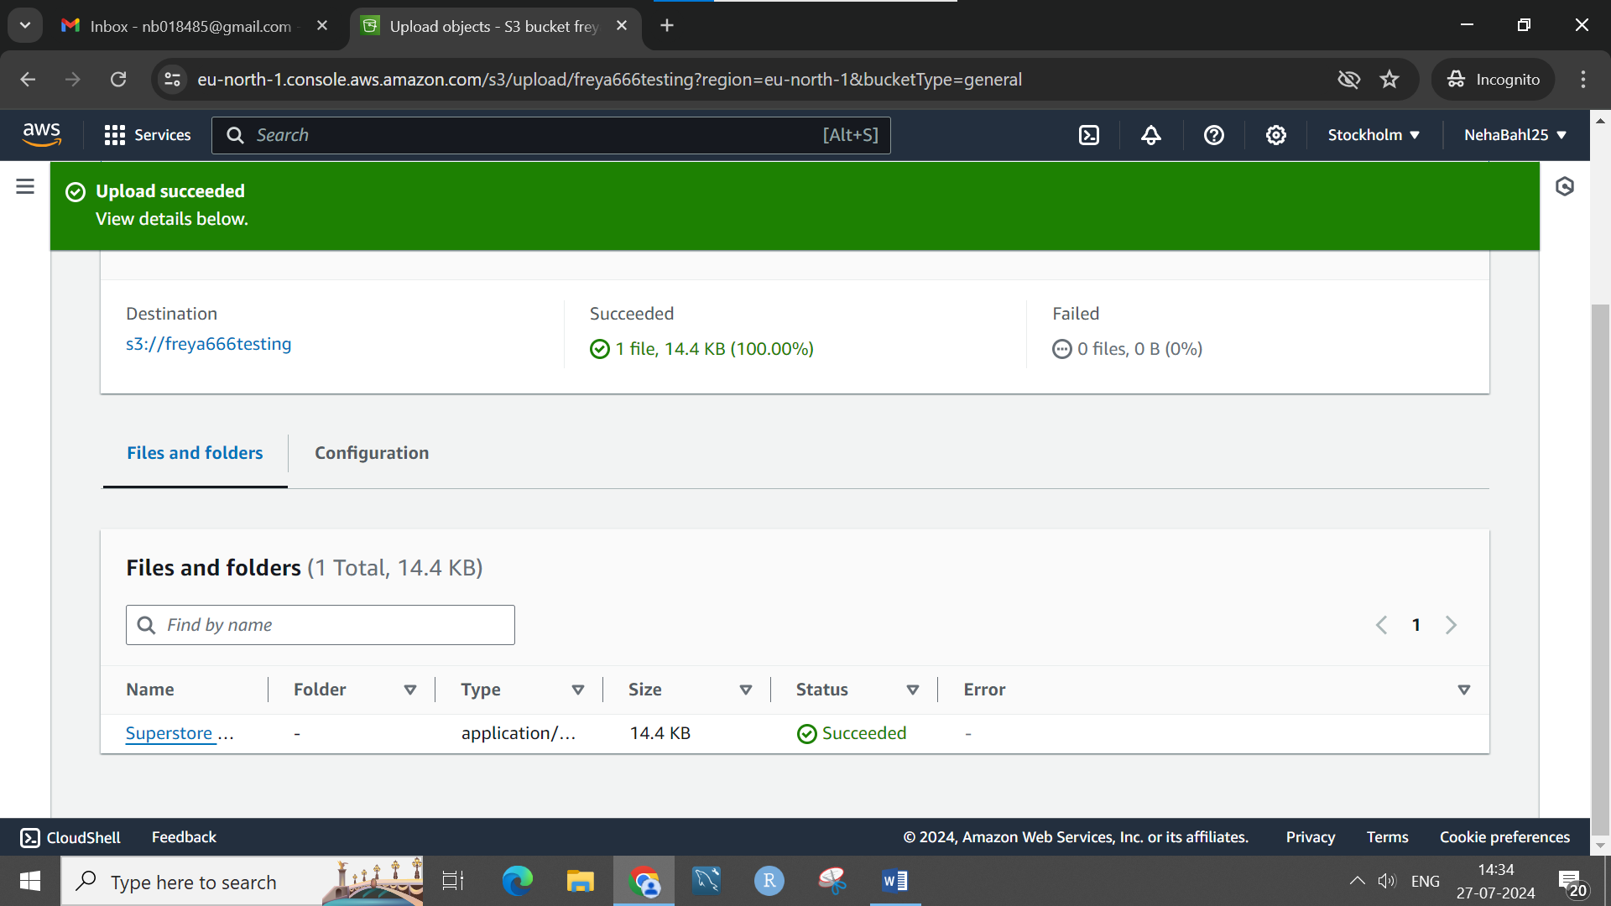

• Once the file is uploaded, click on its name in the S3 console.

• In the **Object details** section, you’ll see an **Object URL**.

• Click on the URL or copy and paste it into your browser to access the file.

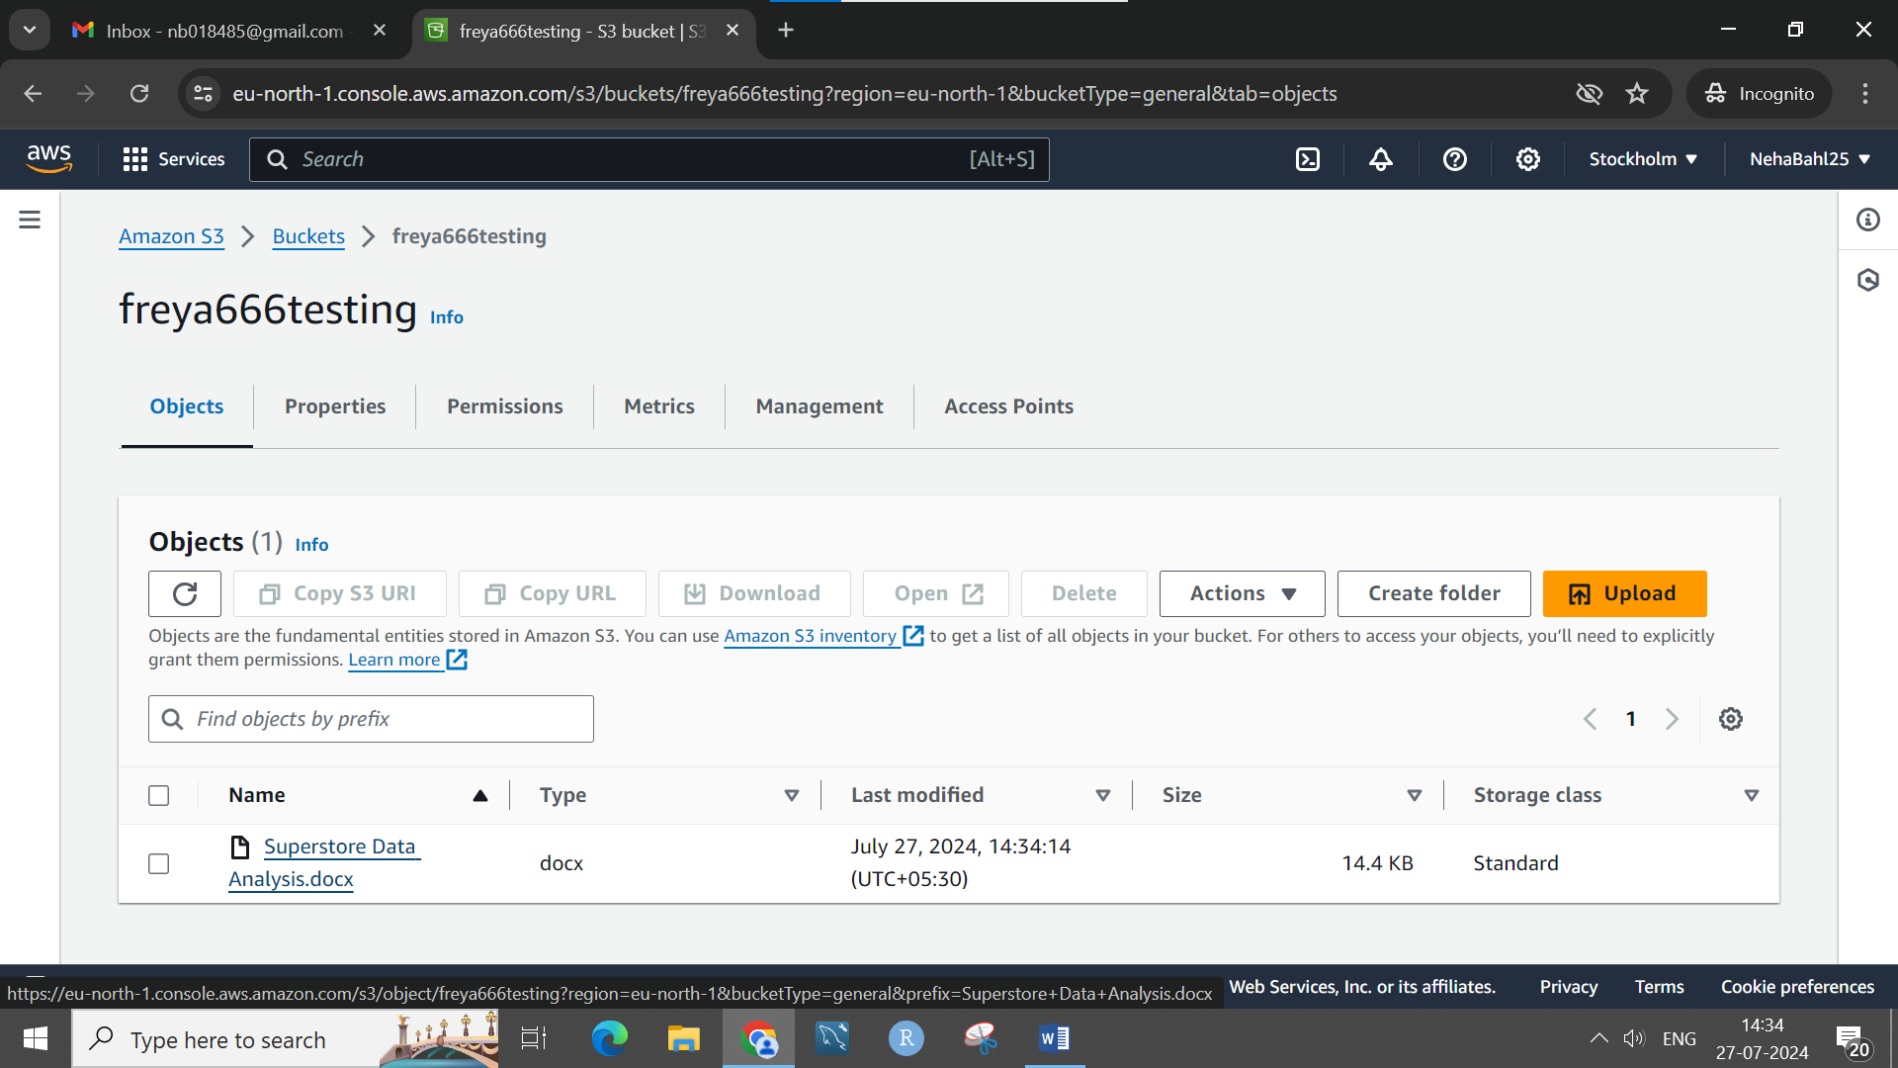

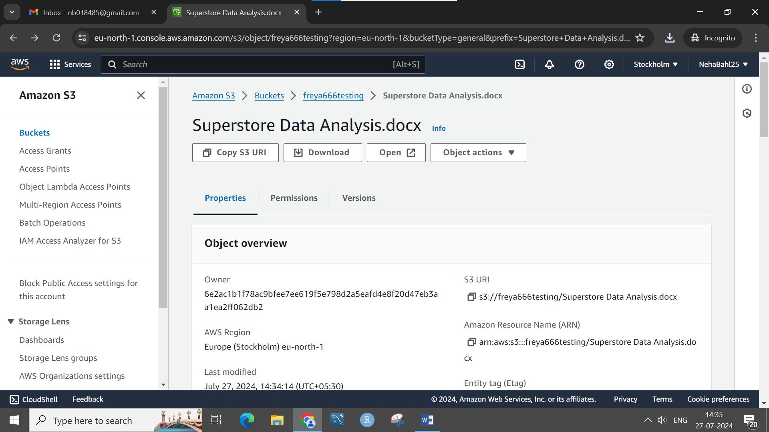

Delete after that

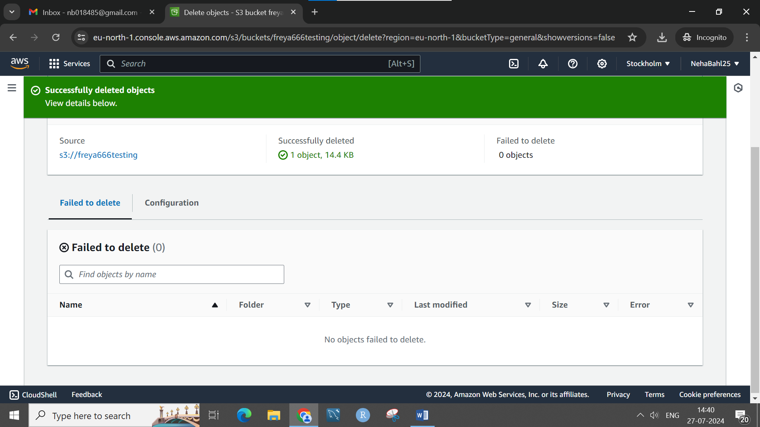

#####2

Go to javatpoint and copy the code paste it into notepad and save as a html extension. Now upload that into s3

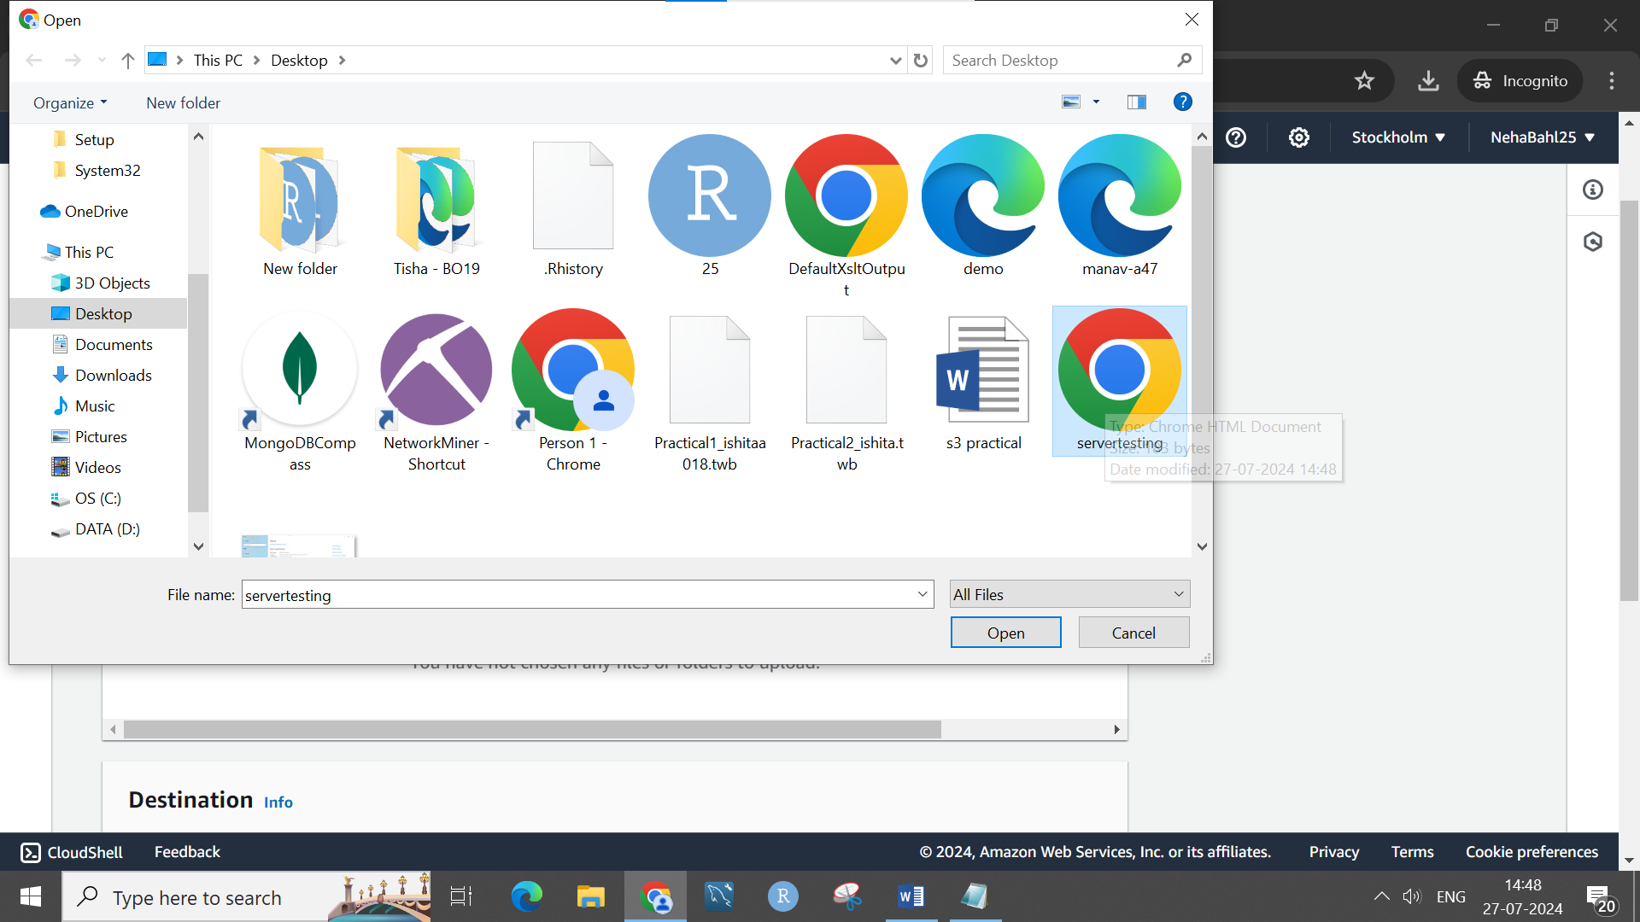

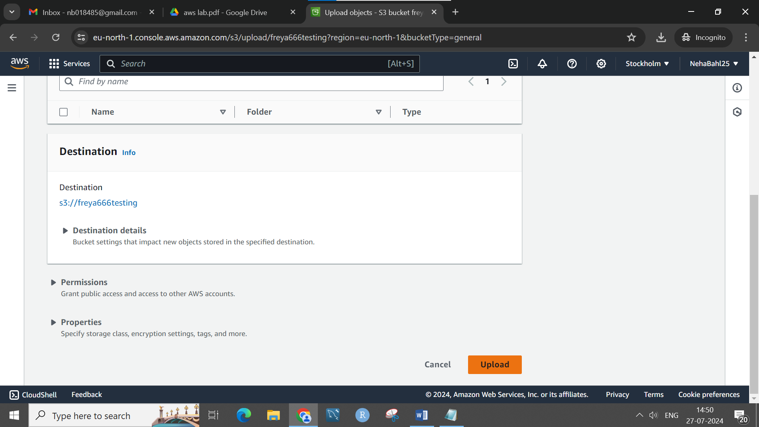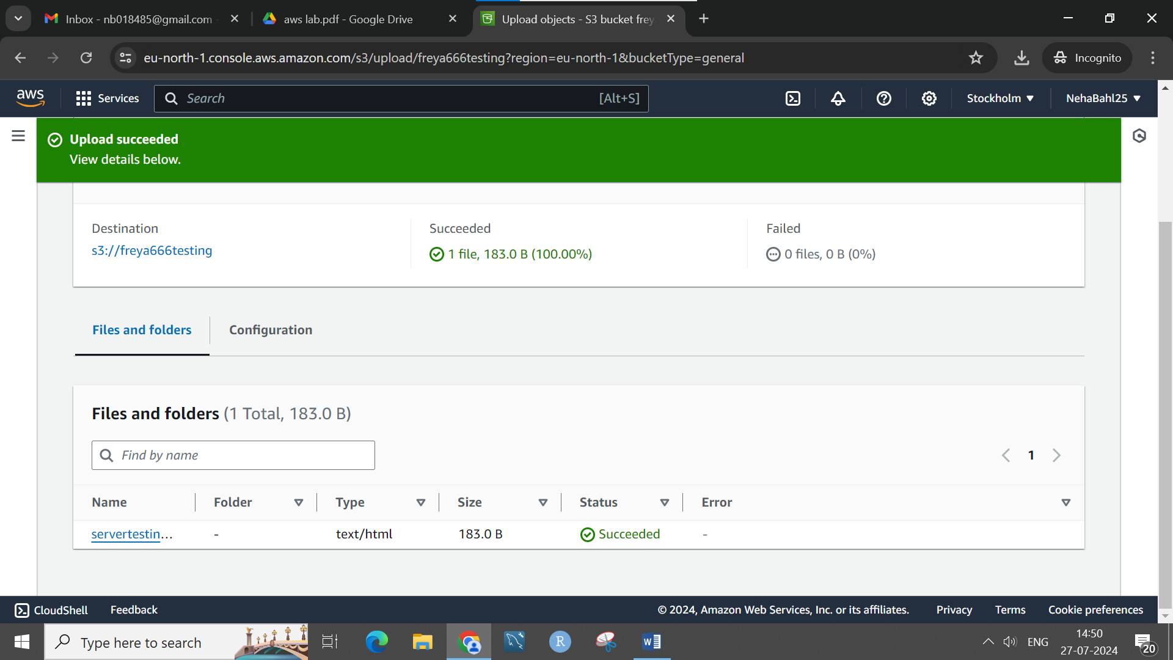

Now open the file fby clicking on -open

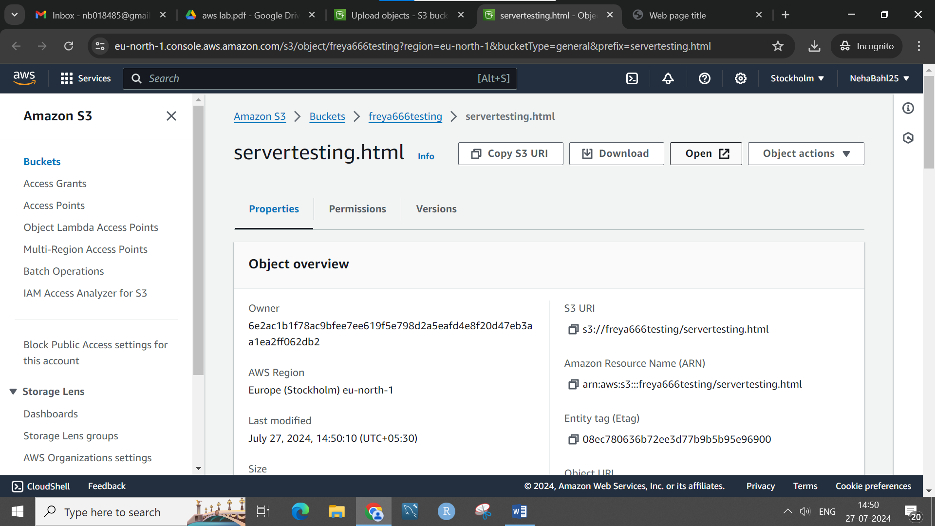

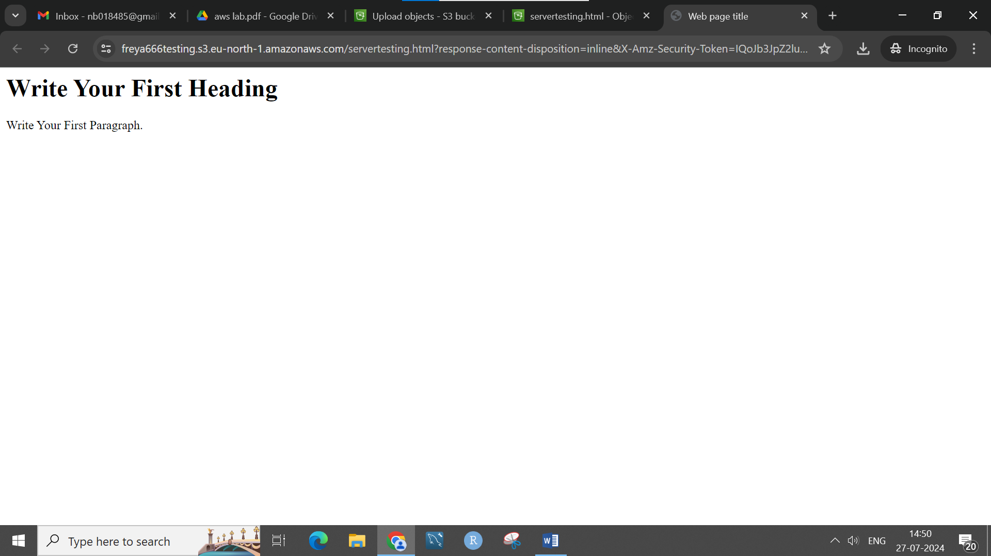

Webpage opens